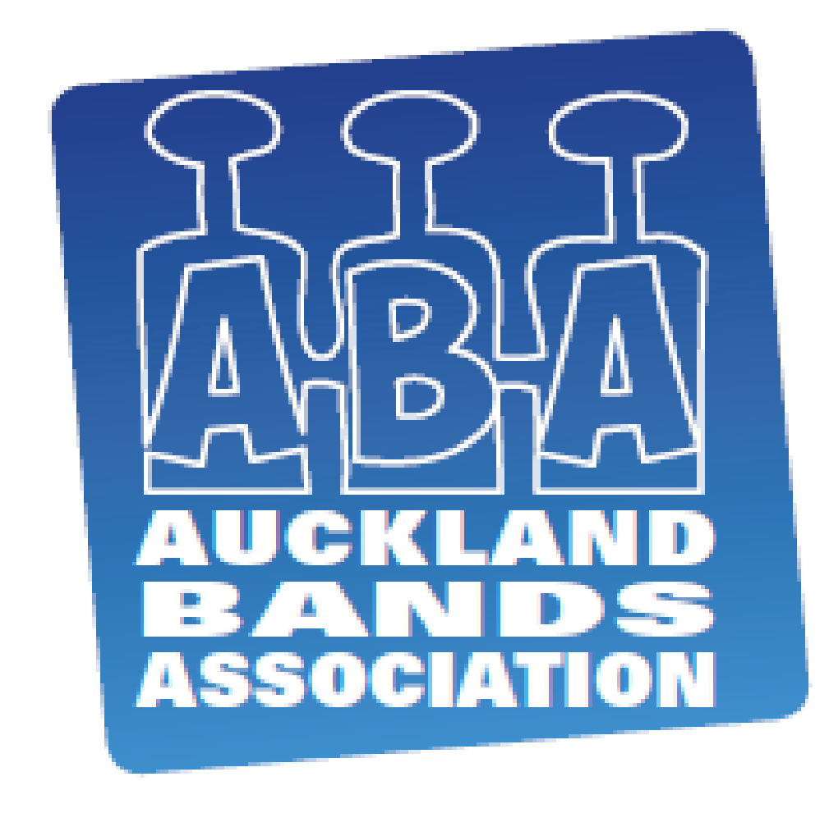
THE AUCKLAND BANDS ASSOCIATION (INC)

YOUTH / AUXILIARY BAND CONTEST RULES

- Two weeks prior to the contest, each competing band is to submit to the Contest Manager a list of names of players on stage, including age and years playing experience, and registration details as to which band the player is currently registered with. This list is to be submitted to the judge prior to the contest, and the judge will be instructed to concentrate on the less experienced players when determining points.

- Scores for the music will be supplied to the Contest Manager with the entry form.

- Points will be allocated at the discretion of the judge, but equally divided on:

  - Music – suitability to the band and the contest, as well as actual performance (tuning, intonation, dynamics, musicality etc.)
  - Entertainment – onstage appearance, discipline, conception, ability to hold attention.

- There will be a time limit of thirty (30) minutes, including the set up and pack down of stage, with points being deducted at one point per minute over the time limit. After forty (40) minutes, bands will be asked to leave the stage by the supervisor.

- Any competing band shall have a minimum personnel of twelve (12), with no upper limit.

- There is no age limit for players.

- Music will be at the discretion of the band.

- Each band must provide a compere (or comperes), with an age limit of twenty one (21). This aspect will be judged separately, and a trophy awarded.

- Each band must feature a solo item with full band involvement in the programme. There will be a trophy awarded to the winning soloist.

- The judge will decide the winning band, and a trophy will be awarded.

- Inclusion of helpers to have no enhancement factor to overall performance.

- Only to include brass instrumentation and percussion.

- Separate Contest Fee Registration required with ABA.

